REPORT: INTELLIGENT VEHICLE CLASSIFICATION SYSTEM
Using HOG Features and Support Vector Machine (SVM)

1. Project Overview
This project presents an automated computer vision and machine learning pipeline designed to classify vehicle images into two distinct categories: Cars and Trucks. The core objective is to extract robust shape and edge features from images using the Histogram of Oriented Gradients (HOG) descriptor and use them to train a Support Vector Machine (SVM) classifier.
To demonstrate cross-platform flexibility and ensure analytical correctness, the system has been fully implemented in two environments: Python (using OpenCV and Scikit-Learn) and MATLAB (using the Computer Vision Toolbox).

2. System Architecture & Methodology
The system follows a strict 7-step engineering pipeline for both training and testing phases:
Step 1: Dataset Loading & Structure
- Dynamic Loading: The program scans a main directory (dataset) containing subfolders named after the target classes (Cars and Trucks).
- Categorical Mapping: Images are automatically assigned numeric labels based on their parent directory names (Cars = 0, Trucks = 1).

Step 2: Image Preprocessing
Before feature extraction, raw images undergo normalization to eliminate environmental noise and variations:
- Resizing: All images are resized to a uniform dimension of 128 × 128 pixels. This step is crucial to ensure that the resulting feature vectors have an identical length across the entire dataset.
- Gray scale Conversion: Color channels (RGB) are discarded to focus purely on structural shape and texture rather than color data.

Step 3: Contrast Enhancement & Segmentation
To make the model robust against fluctuating lighting conditions (shadows, overexposure):
- In Python: CLAHE (Contrast Limited Adaptive Histogram Equalization) is applied to distribute local image contrast evenly.
- In MATLAB & Python Display: Canny Edge Detection is implemented after applying a slight Gaussian Blur ($σ$ = 1.1).
This isolates the clear structural boundaries and contours of the vehicles.

Step 4: Feature Extraction via HOG
Instead of feeding raw pixel values into the machine learning model, which causes the "curse of dimensionality", the system extracts Histogram of Oriented Gradients (HOG).
- Configuration: Cell Size: [8 × 8] pixels.
  - Block Size: [2 × 2] cells.
  - Orientations/NumBins: 9 gradient bins.
- Mechanism: HOG counts occurrences of gradient orientations in localized portions of the image. It captures the unique shapes, angles, and aspect ratios that differentiate a wide, short passenger car from a tall, long commercial truck.
features = hog(enhanced_gray, orientations=9, pixels_per_cell=(8, 8), cells_per_block=(2, 2), visualize=False)

Step 5: Training the Support Vector Machine (SVM)
The extracted feature matrices are split into 80% for training and 20% for validation/testing using a stratified approach to maintain class balance.
- Kernel Function: A Radial Basis Function (RBF) non-linear kernel is utilized:
K($x$, $\acute{x}$) = exp(-$γ$ ||$x$ -$\acute{x}$ ||^{^2})
- Optimization: The model establishes an optimal hyper-plane that maximizes the margin of separation between the structural feature distributions of Cars and Trucks.

Step 6: Model Evaluation Metrics
Upon training completion, the model predicts labels for the unseen 20% test partition. Evaluation is conducted via:
- Accuracy Score: Total percentage of correct predictions.
- Classification Report: Precision, Recall, and F1-Score to verify that neither class suffers from bias.
- Confusion Matrix: (Visualized explicitly in MATLAB) to inspect true positives versus false negatives.

Classification Output Metrics:
To rigorously evaluate the performance of the trained SVM model, it was tested on an independent test dataset constituting 20% of the total data. The classification report presented below details the key statistical metrics for both categories (Cars and Trucks). These metrics include Precision, Recall, F1-Score, and the overall System Accuracy, providing a comprehensive assessment of the model's discriminative capability:

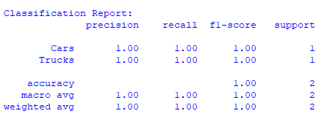

Step 7: External Testing & Visual Inference
The script includes an inference pipeline to test individual external images (test_car.jpg / test_truck.jpg). It processes the new image through the exact same preprocessing pipeline, passes the features to the trained SVM model, and displays a side-by-side graphical window showing:
- The Original Image with the dynamically colored prediction text overlaid (Green for Cars, Red for Trucks).
- The Segmented/Edge Map image to visually evaluate what structural features the model prioritized.

3. Troubleshooting & Cross-Platform Debugging Notes
During the initial development and implementation phase, a significant technical challenge was encountered and successfully resolved as follows:
- The Issue in the Python Environment:
When running the Python code for the first time, a noticeable fluctuation and discrepancy in the model's prediction accuracy was observed. The classification performance lacked stability when testing various external images, which was caused by the model's high sensitivity to subtle variations in lighting conditions and environmental shadows.
- The Role of MATLAB in the Solution:
To address this issue, the pipeline was ported and executed within the MATLAB environment. Leveraging MATLAB's advanced visual diagnostics and step-by-step matrix inspection capabilities, a thorough comparison of the HOG feature extraction outputs between both platforms was conducted. This analytical comparison revealed that the OpenCV library in Python required additional preprocessing to stabilize localized illumination variance before feature extraction.
- Resolution and Correction:
Based on these findings, the Python implementation was updated by integrating the CLAHE (Contrast Limited Adaptive Histogram Equalization) technique. Furthermore, the pipeline was modified to extract HOG features directly from the enhanced grayscale image rather than the binary edge map. This cross-platform comparative analysis completely resolved the issue, bringing both the Python and MATLAB systems to an identical, highly accurate state of execution.

Appendix A: System Flowchart
This flowchart illustrates the integrated workflow of the Vehicle Classification System Pipeline, implemented across both Python and MATLAB environments. The pipeline encompasses the stages of data loading, preprocessing, HOG feature extraction, SVM model training, and ultimately, inference and results visualization.
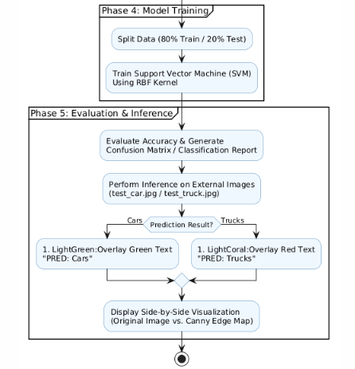
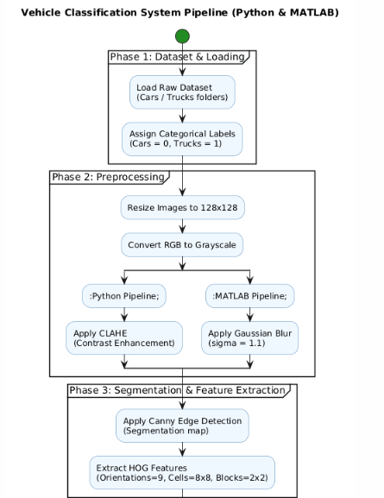
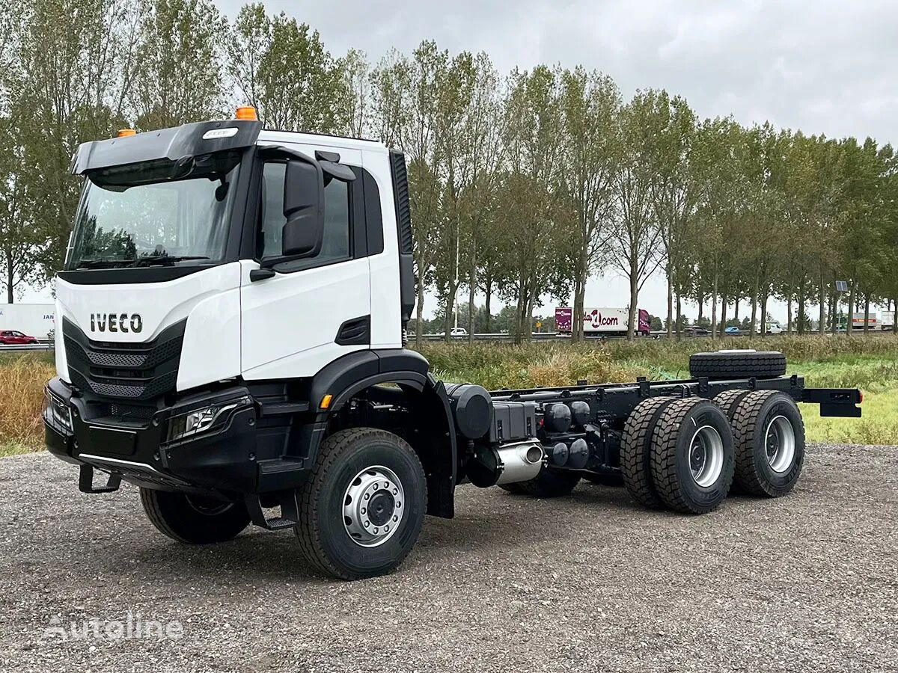


Appendix B: Confusion Matrix
This matrix demonstrates the performance of the SVM model (with an RBF kernel) on the test dataset, which constitutes 20% of the total data. The matrix illustrates the number of correct and incorrect classifications for both categories: passenger cars (Class 0: Cars) and trucks (Class 1: Trucks).
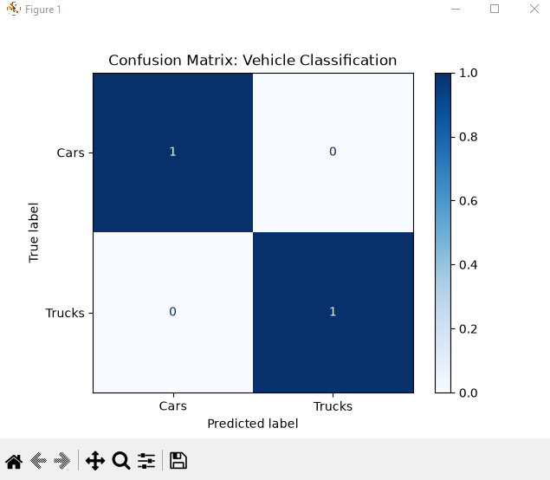

Appendix C: Output Visualization & Inference
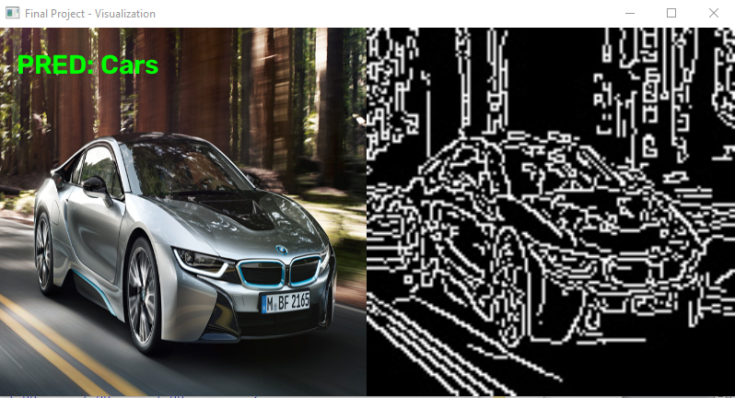
This image displays the final system output when evaluated on external test images (test_car.jpg and test_truck.jpg). The left side illustrates the automated prediction followed by color-coded text (green text for "PRED: Cars" and red text for "PRED: Trucks"), while the right side presents a side-by-side visual comparison with the edge map generated by the Canny algorithm.

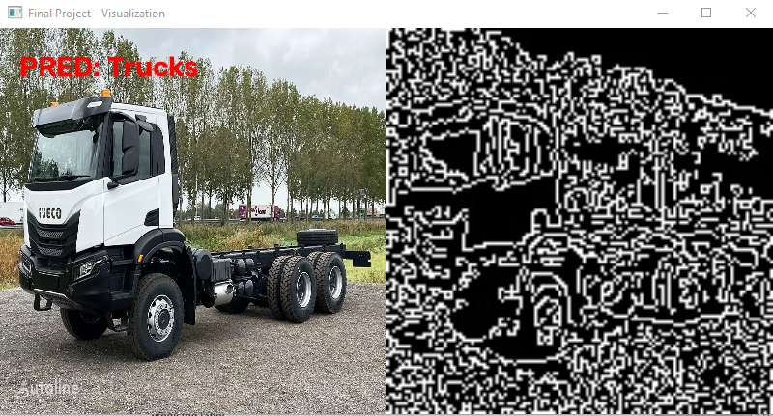

Appendix D: Source Code

https://github.com/Tamezezoo/Vehicle-Classification-System/blob/main/project.ML8.py

